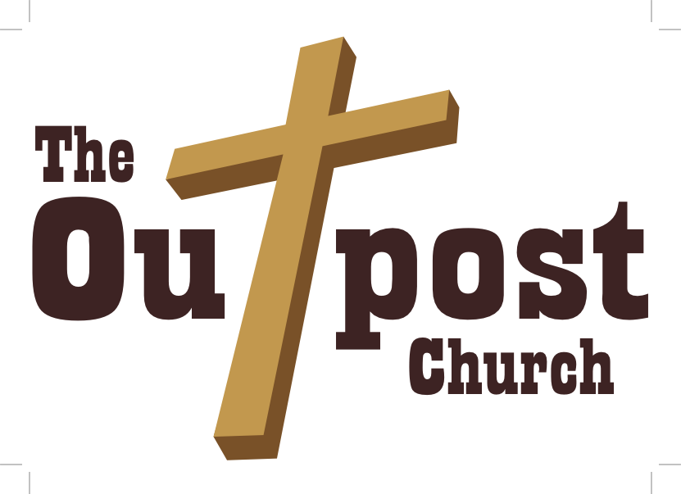

**To advance the Kingdom of God by helping people reach their maximum potential as disciples of Christ.**

**The Outpost Church / 1010 South Dr. / St. Charles, MO / 63301 / 636-373-0745**

**The Vision of The Outpost**

The diagram below represents the New Testament church, and illustrates the primary components of what the church is called to be.

**The Church**

**DISCIPLESHIP**

**PRESENCE**

**WORSHIP**

**SACRAMENTS**

**INWARD LIFE**

**HEALING**

**TRUTH**

**CALLING**

**OUTWARD MISSION**

**The Kingdom of God**

**COMMUNITY**

**THE KINGDOM OF GOD** **– The Foundation -** The foundation of the church concerns the Kingdom of God. God, motivated by His great love, is on a mission in the world today, and that mission is to establish His Kingdom upon the earth. If this is truly the primary mission of God, it makes perfect sense that this should also be the primary mission of the church. Central to our mission as a church, therefore, is to facilitate the forward progress of God’s Kingdom upon the earth. This, by the way, is exactly what Jesus taught the disciples to pray for in the Lord’s Prayer: *Our Father in heaven, hallowed be your name, your kingdom come, your will be done on earth as it is in heaven.* (Matthew 6:9-10) Our church will be, by God’s grace, a community of people who are literally governed by the values and culture of God’s Kingdom; a living breathing tangible expression of God’s Kingdom on the earth; a Kingdom “Outpost”. (Isaiah 9:6-7; Matthew 2:1-2,11; Matthew 4:17; Matthew 6:9-10; Matthew 9:35; Matthew 13:24; Luke 1:30-33; Luke 4:42-44; Luke 9:1-2; Acts 1:3; Acts 1:6)

**DISCIPLESHIP – The Roof** – The primary way the church is intended to bring forward the Kingdom of God upon the earth is through the multiplication of effective disciples. This means the primary activity that should occur under the roof of the church is discipleship. This is exactly why Jesus, in His final marching orders commissioned his followers to go into the world and make *disciples* of all the nations. (Matthew 28:18-20) Therefore, central to our mission as a church will be the process of discipleship as we facilitate the metamorphous of people living according to the values and culture of the world system to living according to the values and culture of God’s Kingdom, so the Kingdom of God can then effectively flow through their lives into the world.

**COMMUNITY – The Spiritual Greenhouse -** If the advancement of God’s Kingdom on earth through discipleship is central to our vision, it’s very important for us to understand *what* a disciple is, and *how* we can make them. In the same way a greenhouse provides an ideal environment that’s conducive to the growth, health, and potential of the plants within the greenhouse, the church is intended to be a *spiritual greenhouse* providing the ideal environment for the growth, health, and potential of disciples. As reflected in the illustration of the church above (the spiritual greenhouse), we see that *community* is the primary environment that makes the growth of disciples possible. Further, we see there are 8 primary values within the context of *community* that together create the ideal environment for the growth of disciples to occur. Please note that the concept of community and each one of the 8 primary values that make the growth of disciples possible are further described in Addendum 1 – The Spiritual Greenhouse.

**THE OUTPOST –** The name of our church, The Outpost, is intended to reflect the primary vision of the church which is to forward the Kingdom of God upon the earth.The word “outpost” is defined in Webster’s Dictionary as *a military settlement established in enemy territory*.Our church is therefore intended to be an “Outpost” of God’s Kingdom upon the earth; a kind of *divine military settlement* established on the outskirts of enemy territory for the purpose of expanding the Kingdom of God.

**In view of the above core values, the mission statement of The Outpost Church is:**

**To advance the Kingdom of God by helping people reach their maximum potential as disciples of Christ.**

Addendum 1 – The Spiritual Greenhouse

**COMMUNITY** 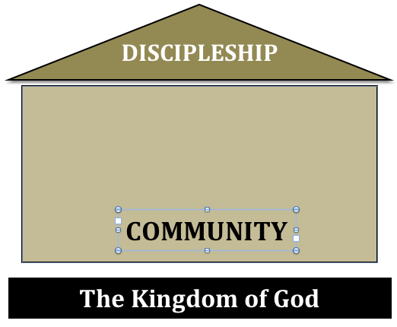

The bible teaches that disciples are formed primarily within the context of Christian *community*. Community is simply defined as open, honest, vulnerable, transparent, and authentic relationship with one another. Community is participating in one another’s lives, being *real* with each other, knowing and being known by one another, and walking in the light together. Community is me letting you “see” who I really am on the inside, and you letting me “see” who you really are on the inside. The Greek word for this concept is the word *koinonia*, and it literally means: *partnership, participation, social intercourse, communication, communion, and fellowship*. The church is intended to be a spiritual *family*, and a true *spiritual family* is a group of people who are experiencing *koinonia* together on a regular basis. This experience of *koinonia* will happen at the Outpost through three primary expressions.

* First, believers will experience *koinonia* with one another on an individual level through authentic, transparent, and vulnerable “one to one” personal relationships.
* Second, believers will experience *koinonia* with one another through a variety of small groups (house churches) that will meet throughout the week at various times. It’s in the context of these small groups that people will have the opportunity to connect with other believers on a regular basis through open, honest, transparent, intimate, and vulnerable relationship.
* Third, believers will experience *koinonia* with one another in the context of our corporate worship service on Sunday mornings.

It’s through these three expressions of community that people will experience the 8 primary values that provide the ideal environment for the growth of disciples.

Please note that additional thoughts on the value of “community” are offered in Addendum 2.

**Value 1: Presence** 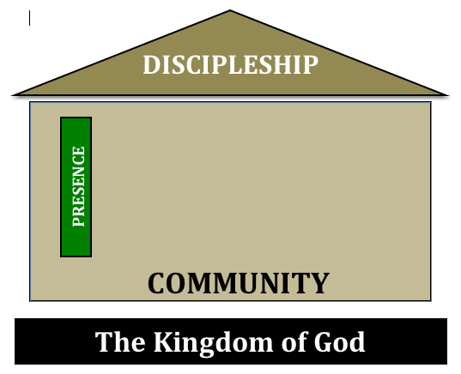

If the head is decapitated from the body, the body has no possibility of experiencing life. Because we are the Body of Christ, and Jesus is the Head of His Body, without the *presence* of Christ in our midst, our attempt at “church” will be utterly futile, and we will experience nothing more than lifeless and powerless “religion”. Because of this, the *presence* of Christ is of supreme importance in our gatherings. When we meet together we are not primarily gathering to learn more information about God cognitively in our heads, but to actually experience the reality, presence, and life of God in our hearts and our lives. Jesus has promised that when two or three believers come together in His name, He will be present with them. Ultimately it is Christ whom we seek, and it is the presence of Christ that has the power to heal, renew, and empower our lives. Because of this reality, the greatest gift we can offer those who would visit our community is not the quality of our music, programs, or preaching, but the presence of Christ Himself.

(Matthew 18:20; Ephesians 1:22-23; Colossians 1:18; John 12:32; I Corinthians 12:12-30)

**Value 2: Worship** 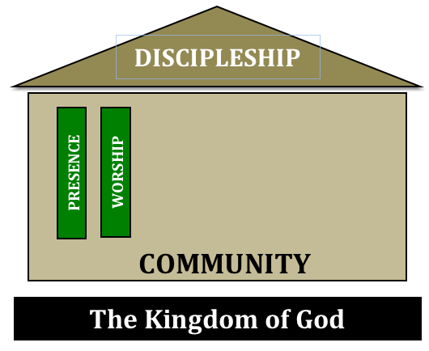

Worship is simply defined as that which I give my heart to; the foremost object of my affection. When I give my heart to something, it will almost certainly get the majority of my thoughts, time, energy, attention, finances, and affection. Said another way, the thing I worship is the center of my life; it’s what I’m living for. For this reason, worship is much more than just singing songs to God, and more accurately concerns the way I’m living my life 24/7. This is what the Apostle Paul was referring to when he said we should offer our bodies as *living sacrifices* to God as our spiritual act of worship. (Romans 12:1) Wow! As we are growing in our relationship with God as individuals, and experiencing His presence corporately in an authentic way, we will be spontaneously compelled to worship God accordingly, not just with the songs we sing in our gatherings, but in the way we are living our lives 24/7; a lifestyle of worship.

(Exodus 20:3; Matthew 10:37-39; Romans 12:1-2)

**Value 3: Sacraments** 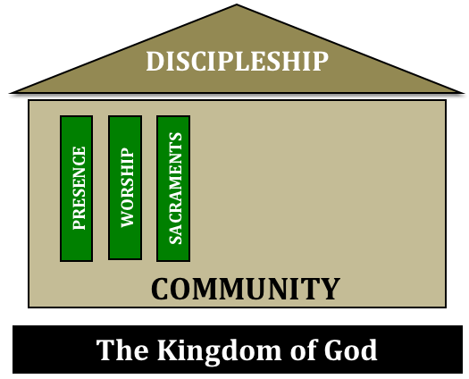

A sacrament is an outward physical symbol intended to represent an inward spiritual reality. There are two sacraments given to the church by God: water baptism and the Lord’s Supper. The sacraments provide a means of public testimony (they are not necessary *for* salvation but are intended to testify *of* salvation), an opportunity for believers to personally identify with the finished work of Christ on their behalf, and should be celebrated as a regular and central part of worship.

**Baptism** – The sacrament of water baptism represents that a person has died to their old life without Christ, they have been buried in the “ground” (represented by the waters of baptism), and resurrected with Christ to walk in newness of life. (Matthew 28:19-20; Romans 6:3-4)

**The Lord’s Supper** – The Lord Jesus, on the night he was betrayed, instituted the sacrament of the Lord’s Supper, to be observed by His Church, until the return of Christ, as a perpetual remembrance and proclamation of His broken body and shed blood. (Matthew 26:26-29; I Corinthians 11:23-26)

**Value 4: Inward Life** 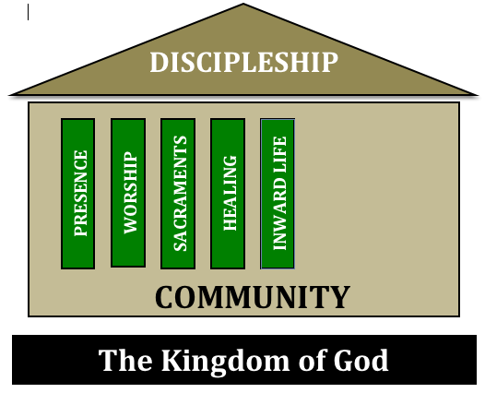

*My worth to God in public is what I am in private.*

*My Utmost For His Highest* / Oswald Chambers / Barbour Publishing 1935 / page 77

An appliance, like a toaster, can only work when it’s plugged into electricity. Water can only flow through a hose when it’s attached to a faucet. A branch can only bear fruit when it’s connected to the vine (John 15:4). In much the same way, a Christian can only experience the life of God when we remain vitally connected to God through personal and intimate relationship. A central distinction between Christianity and virtually every other religion on planet earth is that as Christians, we believe we can experience a personal relationship with the living God. We can know God, love God, talk to God, hear God, walk with God, fellowship with God, and experience God. This connection with God will result primarily from the practice of spiritual disciplines such as bible reading, prayer, fasting, solitude, silence, worship, confession, etc. Individual members of the church communing with God, loving God, and experiencing His life personally will provide the foundation for the Body of Christ to experience the life of God corporately. Ultimately we have very little to offer the world in and of ourselves, but as we commune with Christ and allow the presence of Christ to permeate our lives, our lives will then become the conduits through which the Kingdom of God can flow through us into the world around us. A high priority of The Outpost is to encourage and instruct people in their personal relationship, connection, and love of God.

(John 10:27; John 15:5; II Corinthians 2:14-16; Psalm 25:14)

**Value 5: Healing** 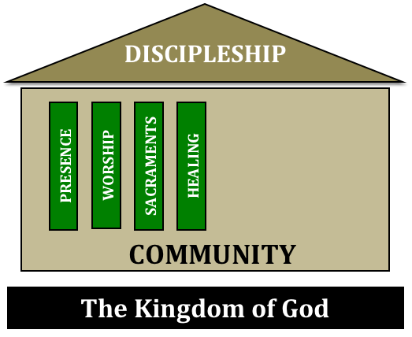

The world we live in is deeply broken, and as a result, humanity in general and each person specifically has been uniquely wounded (Isaiah 53:6; Romans 3:23; John 10:10; Matthew 9:35-36; Matthew 11:28-30). The sin and brokenness of human lives can take on many different forms: depression, addiction, abuse, loneliness, grief, despair, confusion, anger, fear, relational difficulty, etc. We will assume that the majority of people God brings to our community have each experienced their own brokenness in various ways, and therefore a metaphorical “wing” of our church will be a kind of spiritual hospital. With this spiritual hospital we will nurture people toward the healing, health, wholeness, recovery, restoration, and redemption God has intended for their lives. This healing is necessary because a disciple must first experience an authentic level of healing from the brokenness of their own life before they can become an effective channel of the Kingdom of God. In order for a soldier to be effective in battle, he must first have the opportunity to recover from his own wounds. The spiritual hospital will provide a place of respite where people can find the healing they need for their lives so they can eventually be mobilized to the front lines of the Kingdom to fulfill the giftings, callings, and destinies that God has placed upon their lives. Besides the typical functions of the church that offer healing in and of themselves (worship, sacraments, community, truth, etc.), the spiritual hospital will include additional initiatives such as support groups, recovery groups, pastoral counseling, and fee based professional counseling.

(Psalm 147:3; Isaiah 61:1-4; Daniel 4:34; Matthew 9:35-38; 11:28-30)

**Value 6: Truth** 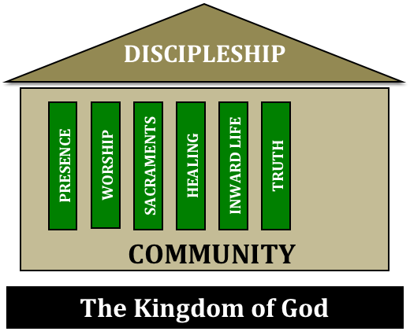

Jesus said they who worship God must worship Him in truth (John 4:24). Doctrinal purity is of utmost importance because the work of God will always be based upon the truth of God. The Outpost will faithfully protect and proclaim the essential truths of the Christian Faith, including:

The existence and triune oneness of God (Deuteronomy 6:4);

The deity of Christ (John 1:1,14);

The virgin birth of Christ (Luke 1:34-35);

Salvation by faith alone in the finished work of Christ (Ephesians 2:8-9);

The divine inspiration of scripture (II Timothy 3:16-17);

Note: for a more complete statement of faith see Addendum 4.

**Value 7: Calling** 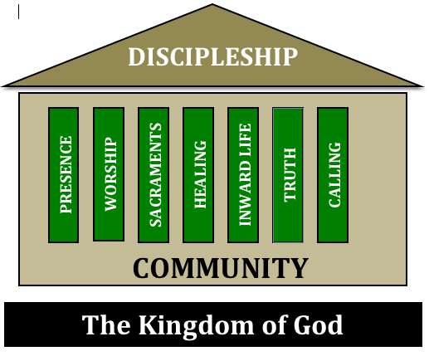

Each believer has been given unique giftings and callings upon their lives; particular and specific ways they are called to serve God on the front edge of the battle as God brings forward His Kingdom upon the earth. Each believer will be most effective in allowing the Kingdom of God to come forward through their life when they are functioning within their God given gifting and calling. A significant part, therefore, of effective discipleship will involve helping believers to identify their giftings and callings, and then “unleashing” people to serve God accordingly, both “inside” (home base ministries) and “outside” (target ministries) the church. Using the metaphor of a battleship, the church will be most effective in battle when the various members of the battleship are each functioning within the battle station assigned to them by God.

(Ephesians 4:11-14; Ephesians 2:10; Colossians 4:17; I Corinthians 3:5; Colossians 1:25; John 17:4; Acts 13:36; Psalm 57:2; Romans 8:28; Ezra 1:2; Jeremiah 1:5; Galatians 1:15; Ephesians 1:4-5; Jeremiah 29:11; Psalm 138:8; Acts 9:15; Acts 13:2; Romans 1:1; I Timothy 1:12; John 18:37; Acts 22:10)

**Value 8: Outward Mission** 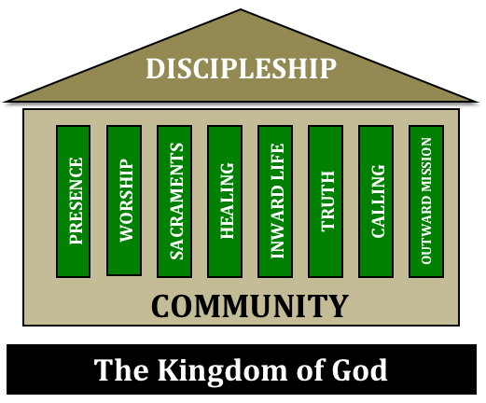

As previously noted, the Mission of God (the missio dei) is to establish His Kingdom upon the earth. The church is intended to be a Kingdom “Outpost” on the earth: a community of people who are governed by the authority of God’s Kingdom, and through which the Kingdom of God is coming. The Kingdom of God is intended to be flowing “into” the church from heaven, and then *through* the church “into” the world! Therefore, a defining characteristic of the church is that she will be continuously engaged in expressions of “outward mission” as the Kingdom of God is flowing *through* her into the world; as individual disciples are unleashed to accomplish exploits for God’s Kingdom based upon their God given giftings and callings (Ephesians 4:11-12). Because of this, a defining priority of The Outpost is to be continuously and effectively engaged in various expressions of “outward mission”, including the preaching of the gospel, ministries to the poor, underprivileged, disenfranchised, sick, rescue missions, those with addictions, prison ministries, nursing home ministries, hospital ministries, inner city ministries, foreign missions, and anything and everything else we are called to do according to the giftings and callings God has placed upon our lives. Believing that Christianity is not intended to be a “spectator” sport, all members of our community are invited, according to God’s will and plan, to participate in outward mission in some capacity.

(Psalm 51:12-13; Eph. 1:4-5, 2:10, 4:12; Col. 1:25, 4:17; I Cor. 3:5; John 15:5; 17:4, 18:37; Acts 9:15, 13:2,36, 20:24, 22:10; Ps. 57:2, 138:8; Rom. 1:1, 8:28; Jer. 1:5, 29:11; Gal. 1:15; Ephesians 2:10; 4:12)

**Note: For additional thoughts on the importance of all disciples being engaged in expressions of outward mission, see Addendum 5.**

Addendum 2 - Community

As previously noted, community is simply defined as open, honest, vulnerable, transparent, and authentic relationship with one another. This idea is affirmed in the many “One Another” principles presented throughout the New Testament.

One Another Principles of The New Testament

* Love one another – I Thessalonians 3:12; 4:9; I Peter 1:22; I John 3:11, 23
* Be devoted to one another – Romans 12:10
* Honor one another – Romans 12:10
* Accept one another – Romans 15:7
* Greet one another – Romans 16:16
* Serve one another – Galatians 5:13
* Care for one another – I Corinthians 12:25
* Admonish one another – Romans 15:14
* Bear one another’s burdens – Galatians 6:2
* Be kind to one another – Ephesians 4:32
* Submit to one another – Ephesians 5:21
* Confess your sins to one another – James 5:16
* Show hospitality to one another – I Peter 4:9
* Fellowship with one another – I John 1:7
* Encourage one another – Hebrews 10:25
* Build up (edify) one another – I Thessalonians 5:11
* Exhort one another – Hebrews 3:13
* We are members one of another – Romans 12:4-5
* Forgive one another – Ephesians 4:32

Clearly, it’s God’s intention that Christians experience the church and the Kingdom of God, not alone, but with “one another”. In view of this, authentic *community* is a central value at the Outpost. (Please remember that our primary goal is to make disciples, and if the primary way to make disciples is in the context of authentic community, then community is of primary and indispensable importance to our vision.) This being said, it should be noted that “church” is not just a building where people meet once a week for 1 to 2 hours on Sunday morning, then go their individual ways to live separate and disconnected lives for the rest of the week. This model of church offers a kind of *aloneness* that enables people to sit in church among hundreds of other people without really connecting, knowing, or being known in any way; a way to *hide* in the open. This kind of church can be likened to a public restaurant, where a person can walk in and sit down in close proximity to complete strangers, have virtually no contact or interaction with those around them, eat their “meal”, and then walk out the door to go back home to live their own private life. This is *not* our vision of “church” at the Outpost. While each person is welcome to participate in our gatherings according to their personal comfort level, they are also invited and encouraged to participate in the authentic *community* that makes us a true spiritual *family* instead of a group of strangers.

Addendum 3 - Statement of Faith

**The Godhead** – There is but one God, the Maker, Preserver, and Ruler of all things; who has revealed Himself as Father, Son, and Holy Spirit without division of essences, attributes, or perfections, yet distinct in person, office, and function. (Deuteronomy 6:4; II Corinthians 13:14; Matthew 28:19)

**Jesus Christ** – Jesus Christ is the only begotten Son of God, pre-existent in the form of God, took upon Himself sinless human nature by the Virgin Birth in order that He might perfectly fulfill the law, suffer and die upon the cross, be buried and rise again on the third day, to reveal God and redeem mankind. His death, burial, and resurrection were representative, vicarious, and substitutionary, and accomplished complete salvation. Now ascended, He is exalted at the right hand of God where He ever lives to make intercession for the saints. (John 1:1-2, 14; Luke 1:35; Romans 3:24-25; 6:1-5; Hebrews 9:24; Romans 8:31; I John 2:1-2)

**Holy Spirit** – The Holy Spirit is the divine person who convicts the world of sin, righteousness, and judgment; and regenerates, baptizes, seals, and indwells all believers unto the day of redemption. He is the author of spiritual gifts and fruit, and continually fills those who yield to Him. (John 16:8-11; I Corinthians 12:12-14; Ephesians 1:13-14; 4:30; 5:18)

**The Scriptures** – The Scriptures of the Old and New Testaments are the verbally inspired Word of God, inerrant in the original writings, infallible, and God-breathed. Thus, they are the final authoritative rule for all faith and life. (II Timothy 3:16-17; II Peter 1:20-21; Matthew 5:18; John 16:12-13)

**Satan** – Satan is a spirit person who was originally created good, yet became the author of sin and cause of the fall of man. He is the declared enemy of God and man, and shall be eternally punished in the Lake of Fire. (Isaiah 14:12-17; Job 1:6-7; Matthew 4:2-11; 25:41; Revelation 20:10)

**The Fall** – Man was originally created in the image and likeness of God, but through the temptation of Satan, he transgressed the command of God and fell from his original state; now he is totally depraved, that is, spiritually dead, morally polluted, and physically mortal. (Genesis 1:26-27; 3:1-6; Ephesians 2:1-3,12; I Corinthians 15:53)

**Salvation** – Salvation from sin and its consequences is the gift of God’s grace, purchased by the death and resurrection of Christ, and received by personal faith in Jesus Christ as Savior. All the redeemed are kept by God’s power, and may rejoice in the assurance of salvation through the testimony of God’s Word. (Ephesians 2:8-10; John 6:37-40; 10:27-30; Romans 8:35-39; I Peter 1:5; Romans 8:14-16; I John 5:13)

**The Church** – The universal Church, over which the Lord Jesus is the Head, is a spiritual organism made up of all born-again persons of this present age. The establishment and continuance of local churches free of any external ecclesiastical authority or control is clearly taught in the New Testament. The local church is governed by the plurality of elders, with equal authority, but subject to the principle of “first among equals”. (1) The ordinances of Water Baptism and the Lord’s Supper are recognized as means of public testimony. (Ephesians 1:22-23; I Corinthians 12:12-14; Acts 14:27; 20:17; I Timothy 3:1-13; Titus 1:5-11; Acts 20:28; Matthew 28:19-20; Acts 2:41-42; I Corinthians 11:23-26)

**Last Things** – The Blessed Hope of the Church is the personal, imminent return of the Lord Jesus Christ for His saints, with whom He shall establish his Millennial Kingdom. Thereafter shall be the bodily resurrection and judgment of the dead, the saved to eternal life, and the unsaved to everlasting punishment. (I Thessalonians 4:13-18; Revelation 19:11-16; 20: 1-6, 11-15; Matthew 25:46)

1. *Biblical Leadership* / Alexander Strauch / Lewis & Roth Publishers 1995 / page 45 - 5

**Vignettes**

**Kids / Youth**

* If families are going to be part of our church, we have to offer a legitimate ministry for their kids and youth to be involved in.
* The goal is not to just offer glorified babysitting with a benign bible lesson attached, but to pursue the true discipleship of our kids as they learn what it means to become authentic followers of Christ.
* If the kids ministry is going to be alive and effective, we need to pray for God to provide leaders who are truly passionate about ministering to kids.
* The presence of kids in our community is incredibly important because they offer life and vitality, and they represent the future of not only our church, but more importantly the Kingdom of God.

**Sunday Service**

* Our Sunday service will be a primary “gateway” through which many people find there way into our community of faith.
* With our Sunday service we will seek to offer a contemporary worship experience that is genuine, authentic, and culturally relevant.
* As reflected in Value 1 above, the *presence* of Christ is of supreme importance in our gatherings, and while we understand the importance of “order” in our gatherings (I Corinthians 14:40), we also want to be sensitive and open to the movements of the Holy Spirit to guide our gatherings according to His will and purposes.

**Seeker Friendly**

* The church is intended to be the living expression of the Kingdom of God upon the earth. As such, when people visit our church community it’s as if they are, in a mystery, stepping from one world into another; from the culture of the world system into the culture of God’s Kingdom. Because of this we will strive to reflect the Kingdom of God as genuinely as possible in our gatherings, and we will *not* deliberately dilute our message or activity in the attempt to be “safer” or more “attractive” to those who are visitors.
* We do *not* believe we are called to somehow project 2 different levels or images of “church” to the world: a kind of watered down benign version intended to persuade seekers that they really should become followers of Christ, and then the “real” version for those who are more serious about God and ready to follow Him accordingly. Instead, we are called to be the real church, as accurately, genuinely and authentically as we can be, and simply let God be in charge of drawing those who are ready to move toward His Kingdom.
* Said another way, Jesus said that if He is lifted up, He will draw men to Himself (John 12:32). Our primary goal is therefore to life up Jesus, and let Him do the “drawing” according to His will and purposes.

**Debt**

* We believe that where God guides, God provides.
* We are therefore committed to operating our ministry on a no debt, pay as you go basis.
* We will therefore seek to raise the necessary funds in advance of any ministry initiatives we believe God is calling us toward.
* This conviction and its implications may actually limit growth potential, but we accept that a smaller church with no debt is fundamentally healthier and preferable to a larger church with debt.

**Leadership**

* We believe the biblical model of church leadership is a plurality of elders / pastors who have final authority in governing the church.
* As such, we are *not* a congregational church that makes decisions based upon congregational vote.
* While each elder / pastor has equal authority, we also recognize the biblical precedent of “first among equals”, or what might be referred to as a “Senior Pastor”.
* The elders will recognize the impossibility of pleasing “all the people, all the time”, and as such they will remain open to the hearts and voices of all members concerning all matters, and then seek to humbly lead the congregation to the best of their ability before the Lord as the servant leaders they are called to be (Matthew 20:25-28).
* Ultimately Jesus is the Head of His church, and every member, including every elder / pastor is under the authority and headship of Christ. (Ephesians 1:22; 5:23)

**Church Planting**

* Because our ultimate goal is to forward the Kingdom of God upon the earth, and the best way to do this is by making disciples, and because the “church” is the most effective way to produce disciples, our vision will always include the planting of disciple making churches that will plant other disciple-making churches.
* Said another way, not only will we forward God’s Kingdom upon the earth by making individual disciples, but we will also forward God’s Kingdom upon the earth by planting disciple-making churches.
* The reason for this is simple: if it’s our goal to produce disciples, it only makes sense that not only should we produce as many *individual* disciples as possible, but we should also open additional disciple making *factories* (churches) that will ultimately lead to the making of even more disciples.
* Based upon this vision it will be our hope to remain perpetually “pregnant” as a church with the next baby “church” that is forming within us, and it will be our intention to “birth” new churches according to God’s leading and will.
* This aspect of our vision will allow aspiring leaders the opportunity to move forward in their Kingdom callings rather than being perpetually “trapped” under the ceiling of existing leadership (I Timothy 3:1).
* It’s recognized the primary obstacle to this part of our vision is the identification and preparation of the next generation of “called” leaders. It’s assumed a ministry “calling” is not granted by men, but by God. If a man is aspiring to leadership but none or few are willing to follow him, it indicates he is not yet “ready” in his calling as a church leader / planter. Said another way, we cannot force people to follow or yoke together with any other person, and trust God will cause new “baby” churches to emerge from our congregation in a spontaneous and organic way as the “leaders” and “followers” necessary for a new church come together according to the plan and purposes of God. The primary way we anticipate this possibility is through the obvious “success” of any particular small group / house church that coalesces in unity and vision under particular leadership toward the birth of a new “baby” church.

**Longevity**

* While it is our intention to function as a church indefinitely, we recognize that Jesus is the ultimate Head of the church, and as such the existence of our church is completely His prerogative based solely upon His will and purposes.
* We recognize that the movements of God tend to ebb and flow according to various “seasons” based upon the purposes of God alone, and since it is not our intention to merely establish a human institution, the longevity of our church will be determined by the sovereign will and purposes of God.

**Home Base vs. Target Ministries**

* As reflected in the vision statement above, we believe every Christian is invited to participate in the forward progress of God’s Kingdom based upon their God given callings.
* That being said, we recognize there are two primary types of ministries in which different believers may feel called to serve, what author Frank Tillapaugh referred to as “Home Base” and “Target” ministries.
* “Home Base” refers to various ministries *inside* the church connected directly with the necessary functioning of the church itself, such as Sunday School teachers, deacons, worship team, etc.
* “Target” refers to various ministry initiatives that will be occurring *outside* the church, such as Oasis Food Pantry, Big Feast, The Power of Purity, etc.
* Observing that many churches end up focusing almost exclusively on their home base ministries to the neglect or exclusion of target ministries, we will always seek to maintain a healthy balance between the two.
* Said another way, we are not called to create a Kingdom “fortress” where people have to find their way to us in order to hear about and experience the Kingdom of God, but we are also called to bring the Kingdom forward into the world. This is the “go” of the great commission (Matthew 28:19). By God’s grace our church will be a launching pad for many target ministries that are forwarding the Kingdom into the community and culture in which we live.
* All ministry initiatives will be governed by 3 primary guidelines:

1. Do not ask for “people”. If a person feels led to begin a particular ministry in the church, but nobody else is interested in participating in that ministry, it could be a clue that *now* is not the right time for that ministry.
2. Do not ask for “money”. While the church may be able to contribute to various ministry initiatives based upon the availability of funds, it’s assumed that “when God guides, God provides”, and each ministry will be expected to be self-funded accordingly.
3. Doctrinal purity.

**Too Much Church**

* It should be noted that the basic ministry template of the Outpost consists of two primary initiatives: Sunday morning service and weekly house churches, or what might be called small groups, life groups, cell groups, or home groups.
* We recognize that we already live in a very high pace society, and it’s not necessarily healthy or appropriate for people to be engaged in “church” activities three, four, five, or more times per week, because folks need to enjoy a reasonable personal and family life.
* If a member of the Outpost attends Sunday morning service, and participates in a weekly house church as well, they are already involved in church activities 2 times per week. Add to that possible involvement in another ministry initiative or outward mission, and before you know it the demands of church participation could begin to place unreasonable expectations upon folks lives.
* In the attempt to be sensitive to this dynamic, we will carefully guard the Sunday morning service and house churches as our foundational ministry template.

**Non-Exhaustive**

* This “manifesto” is obviously *not* exhaustive in nature. How can we possibly capture the divine mysteries of the Church and God’s purposes in just a few pages written by a man? Instead, these pages represent an inadequate attempt to convey a very basic overview of the vision and orientation of what we hope the Outpost might look like.
* A good example of this was an observation from a good friend who commented that “evangelism” was not specifically mentioned in the manifesto. His comment was well taken, and serves as a perfect example of the fact that this document is non-exhaustive.
* It should therefore be noted that this manifesto is not exhaustive in nature, and there are many things are essentially “assumed”.
* An example of this concerns my friend’s observation about evangelism. Although evangelism is not specially mentioned, it is assumed as a significant part of Outward Mission.
* Another example might be prayer. Prayer is obviously profoundly important in the life of the church, and although it is not specifically expanded upon in the manifesto, it is essentially assumed as part of Worship and Inward Life.